Healthcare: Relationships, Queries, and Analysis

Patrick Ha
IS 257 S01 Big Data Analytics
Professor Wibbenmeyer
October 17, 2024

Healthcare: Relationships, Queries, and Analysis
Focus Question 1) How do we lower the prescription drugs prices by making a deal between insurance and markets for patients to pay lower drug prices? The column family store model will be best for this, because it is going to help with the time series data the data will help answer if the patient cost for buying will increase or decrease in the future
Query 1) This query answers this question: Is the insurance reimbursement covering all or most of retail price? When the retail price is lower or higher, the insurance reimbursement can cover more than half the retail price most of the time. There is an exception when retail price is at $30000, insurance reimbursement is $10000. The query shows where insurance_reimbursement is less than retail price.
SELECT Insurance.Insurance_reimbursement,Prescription_Cost.Retail_Price
FROM Insurance
INNER JOIN Prescription_Cost ON Insurance.Insurance_id = Prescription_Cost.Insurance_id
WHERE Insurance.Insurance_reimbursement < Prescription_Cost.Retail_Price;
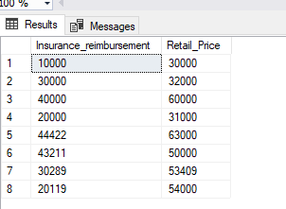
Query 2-used for Identify Filters, Aggregations, and Charts) This query answers this question: Is the patient cost for buying increasing or decreasing in the future? We can see that in the year 2000 it was $37,000, and then the year 2001 it increased to $53,081. It seems like the average patient cost for buying prescription is increasing by year. If nothing is done to try to make a deal between the insurance and markets, then it is likely that next year it will increase as well.
SELECT
YEAR([date]) AS year,
AVG([Retail_Price]) AS avg_patient_cost
FROM
Prescription_Cost
GROUP BY
YEAR([date])
ORDER BY
year;
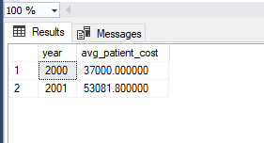
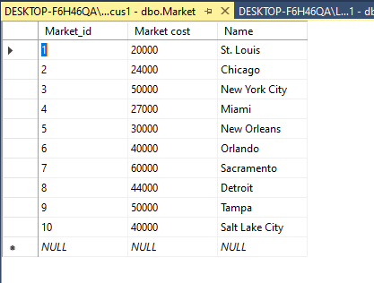
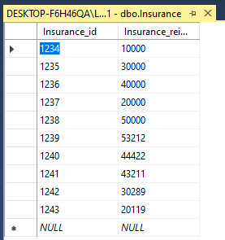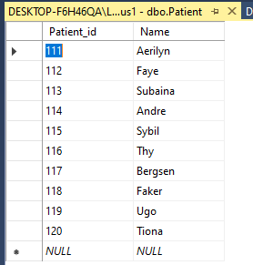

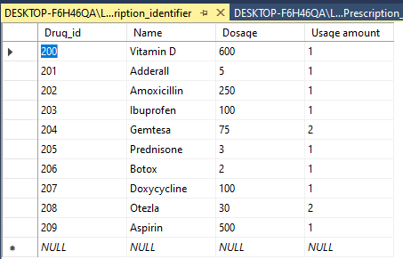
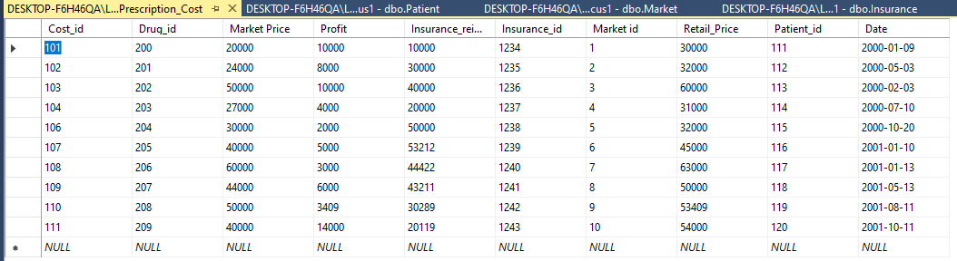

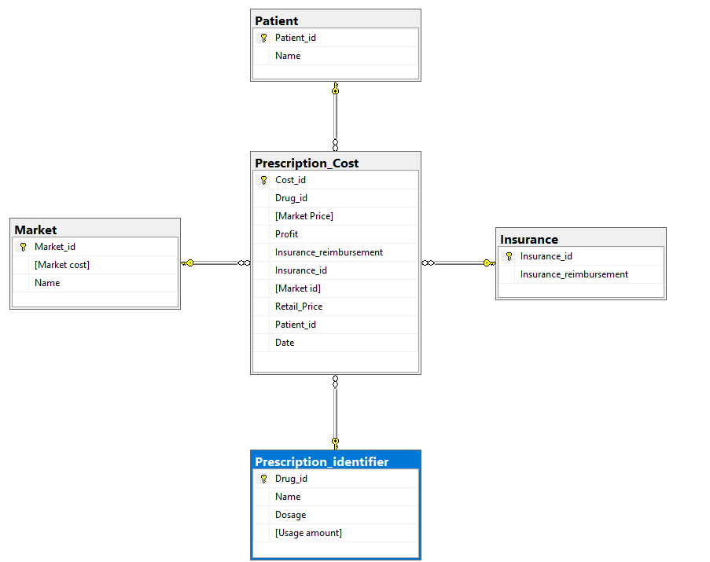

This ERD shows the Prescription Cost table being the fact table, and the dimension tables are Patient, Market, Insurance, and Prescription Identifier. The market price, profit, insurance reimbursement, and retail price are the quantitative data.
Focus Question 2) How to reduce time for contacting doctors between doctors and patient by implementing mobile software to reduce wait time?
Query 1-used for Identify Filters, Aggregations, and Charts) Does the appointment time have a correlation with difference between mobile and without mobile time? Yes, there seems to be a correlation between appointment time and difference between mobile and without mobile. The times like early in the morning, doctors are seeing many people during this time. Using the mobile software can drastically reduce the wait time. People that do not use the mobile app have to wait to get in line.
SELECT [Appt_time], Difference_in_mobile_time_and_without_mobile
FROM Appointment;
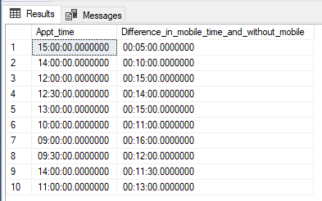
Query 2) Does the availability of the doctor and difference mobile and without mobile reduce the time between doctors and patients? There does not seem to be a correlation between the availability of the doctor and time difference mobile and without mobile. When there are multiple doctors available in one day, the time difference doesn't seem to reduce much or increase by much.
SELECT
Availability,
Difference_in_mobile_time_and_without_mobile AS time_diff,
COUNT(*) AS total_appointments,
SUM(CASE WHEN Confirmed_apptments = 1 THEN 1 ELSE 0 END) AS confirmed_appointments
FROM
Appointment
GROUP BY
Availability, Difference_in_mobile_time_and_without_mobile
ORDER BY
Availability, time_diff;

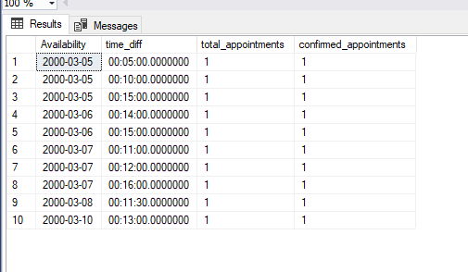
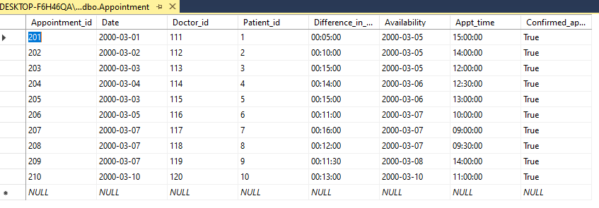

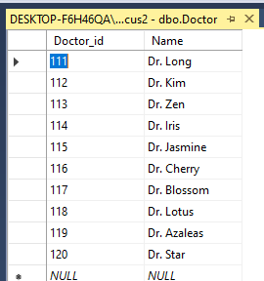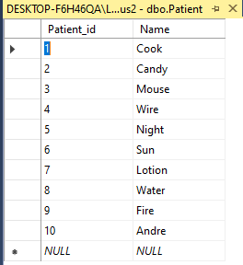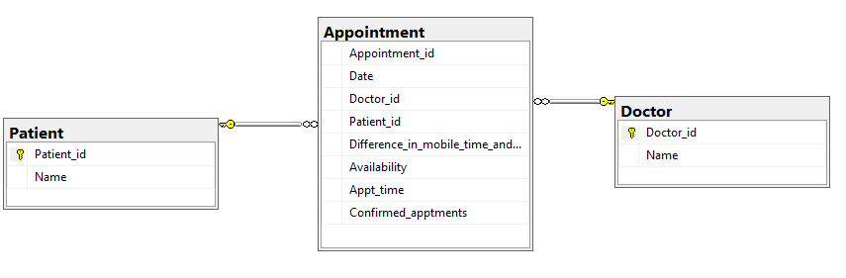
This ERD shows the Appointment table being the fact table and the dimension tables are the Patient and Doctor.
Focus Question 3) How to reduce overall health expenditures between health sectors by using software to reduce health costs for the country?
Query 1-used for Identify Filters, Aggregations, and Charts) Which health sector contribute the most in health expenditures? The hospital cost has the most contributes most. We should look into the hospital sector and try to find out what is contributing or what kind of things they are doing that is having them having to use more money. There may be some things that can be improved on.
SELECT SUM(Dcost) AS Total_DentistCost, SUM(Hcost) AS Total_HospitalCost,SUM(Pcost) AS Total_PharmaceuticalsCost, SUM(Ocost) AS Total_OtherCosts
FROM Expenditures;

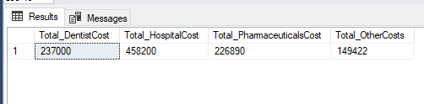
Query 2) Which health sector contributes the least amount and what software in health expenditures? Other Health costs give the least amount of contribution to the health expenditure. Quicken, Monkey Dance, and Excel software was used. We can look into these software to see how it is used. It may be one of the reasons why Other Health costs is using less money than the others.
SELECT SUM(Dcost) AS Total_DentistCost, SUM(Hcost) AS Total_HospitalCost,SUM(Pcost) AS Total_PharmaceuticalsCost, SUM(Ocost) AS Total_OtherCosts, Expenditures.Software
FROM Expenditures
INNER JOIN Dentist ON Dentist.Dentist_id=Expenditures.Dentist_id
INNER JOIN Hospital ON Hospital.Hospital_id=Expenditures.Hospital_id
INNER JOIN [Other Health] ON [Other Health].Health_id=Expenditures.Health_id
INNER JOIN Phramaceuticals ON Phramaceuticals.Drug_id=Expenditures.Drug_id
GROUP BY Expenditures.Software;

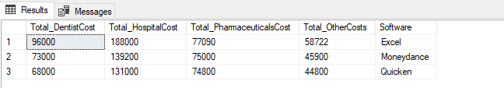

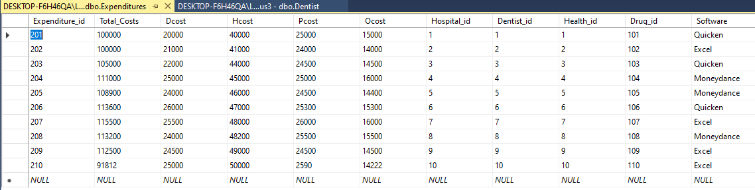
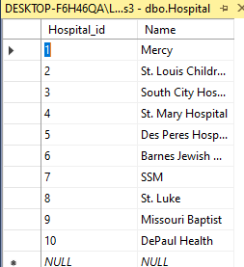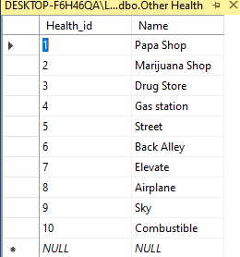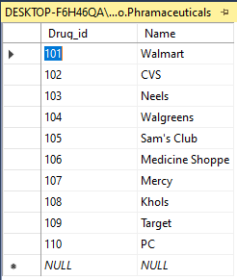
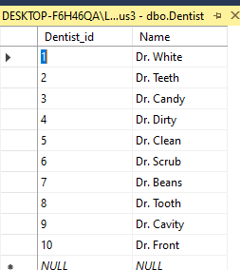

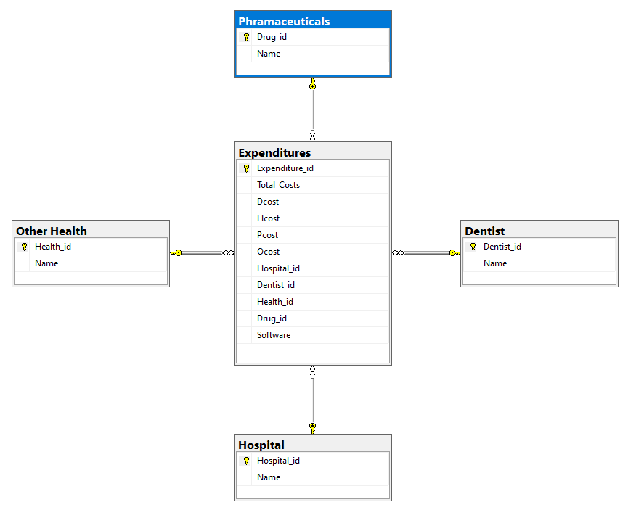
This ERD has the fact table expenditures and the dimensional tables Pharmaceutical, Other Health, Dentist and Hospital.
Focus Question 4) How to improve price transparency for patient health costs by using software to improve price accuracy?
Query 1-used for Identify Filters, Aggregations, and Charts) Which health sectors give patients the most accurate price transparency? The Other Health difference has at least difference between the estimate and cost is the most accurate. We should look at what kind of software they are using and what kind of financial estimate and cost they do.
SELECT SUM([Hosital_Difference_in_estimates/costs]) AS Hospital_Difference,SUM([Dentist__Difference_in_estimates/costs]) AS Dentist_Difference,SUM([Insurance_Difference_in_estimates/costs]) AS Insurance_Difference,SUM([Other_Health_Difference_in_estimates/costs]) AS Other_Health_Difference
FROM Price_Transparency;
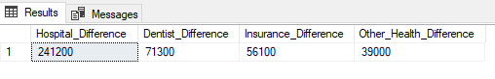
Q2: Which estimator tool is most accurate in price transparency? It looks like the Buxfer estimator tool is the most accurate for estimating the cost for patients. We would look into the software and see what kind of things the software implements that makes Buxfer be accurate.
SELECT SUM([Hosital_Difference_in_estimates/costs]) AS Hospital_Difference,SUM([Dentist__Difference_in_estimates/costs]) AS Dentist_Difference,SUM([Insurance_Difference_in_estimates/costs]) AS Insurance_Difference,SUM([Other_Health_Difference_in_estimates/costs]) AS Other_Health_Difference, Price_Transparency.Estimator_tool
FROM Price_Transparency
GROUP BY Price_Transparency.Estimator_tool
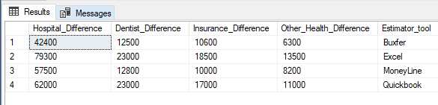
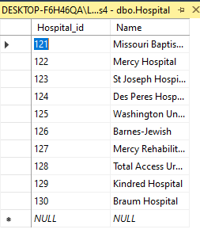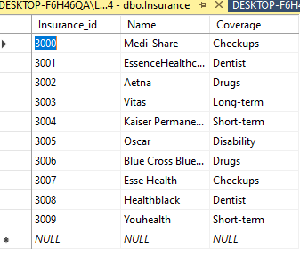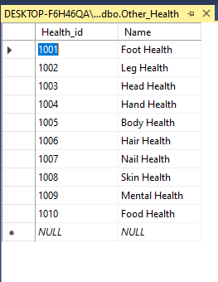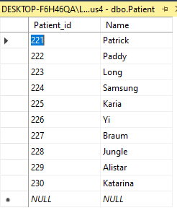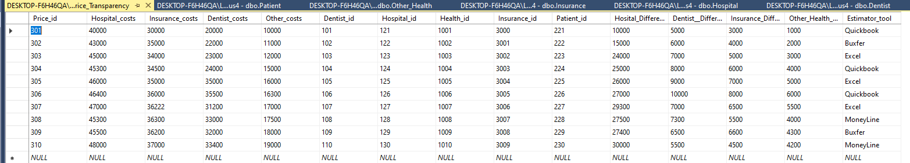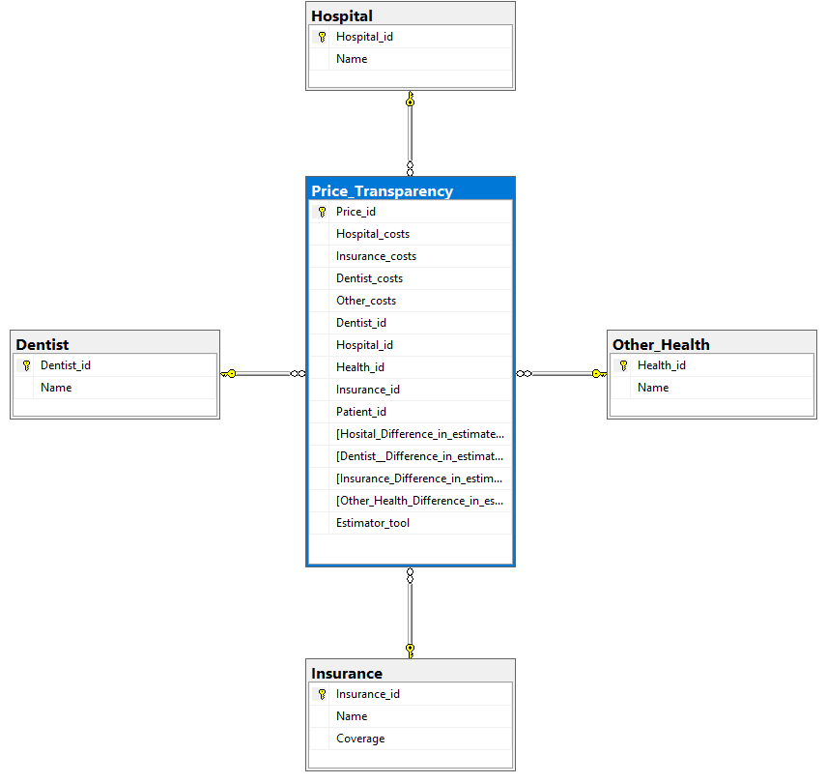

This ERD has a Price Transparency fact table, this table has all the costs, and it has dimensional tables: Hospital, Dentist, Other Health, and Insurance.

